**Appendix 4a: Assumptions test indirect path**

Value p-value Decision

Global Stat 7.646553 0.10542 Assumptions acceptable.

Skewness 2.452351 0.11735 Assumptions acceptable.

Kurtosis 4.250997 0.03923 Assumptions NOT satisfied!

Link Function 0.940023 0.33227 Assumptions acceptable.

Heteroscedasticity 0.003182 0.95502 Assumptions acceptable

**Appendix 4b: assumption test direct path Points Difference**

Value p-value Decision

Global Stat 442.7895 0.000e+00 Assumptions NOT satisfied!

Skewness 43.0247 5.405e-11 Assumptions NOT satisfied!

Kurtosis 396.1679 0.000e+00 Assumptions NOT satisfied!

Link Function 3.0012 8.320e-02 Assumptions acceptable.

Heteroscedasticity 0.5957 4.402e-01 Assumptions acceptable.

**Appendix 4c: assumption test direct path Goal Difference**

Value p-value Decision

Global Stat 253.05579 0.00000 Assumptions NOT satisfied!

Skewness 0.75124 0.38608 Assumptions acceptable.

Kurtosis 248.47293 0.00000 Assumptions NOT satisfied!

Link Function 3.82617 0.05046 Assumptions acceptable.

Heteroscedasticity 0.00545 0.94115 Assumptions acceptable.

**Appendix 5a: Normality plot indirect path** 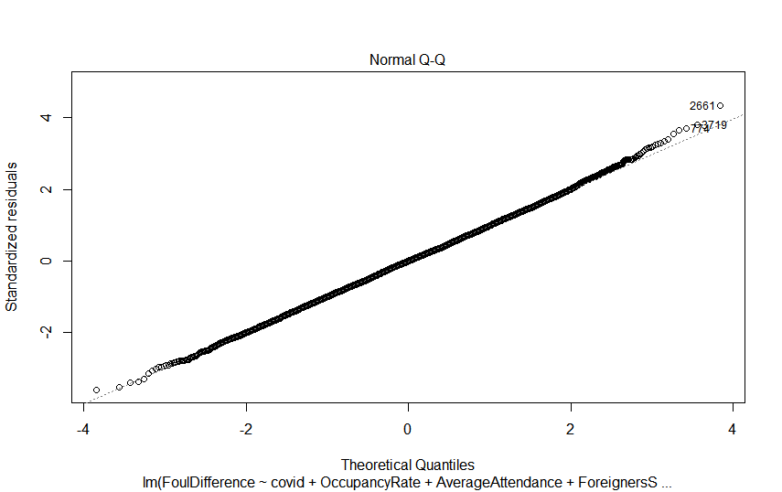

**Appendix 5c: normality direct path Goal Difference:**

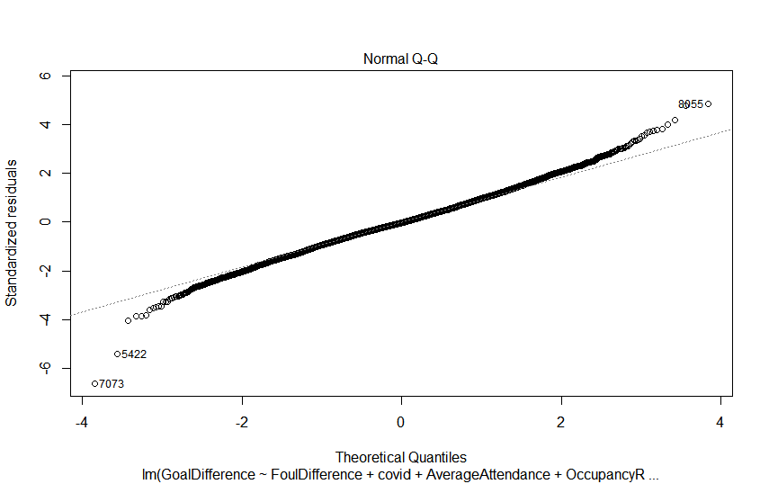

**Normality:** The Anderson-Darling tests show that our variables are not normally distributed, the results of these tests are shown in appendix 2a. To assess multivariate normality we use the globalized gvlma test, which tests multiple assumptions of linear regression in combination to eachother. Pena & Slate (2006) mention, assumptions are often interrelated with eachother, which makes the combined test powerful as it takes these interactions into account. The test result in appendix 4a, 4b and 4c show that similar to univariate normality, the assumption of multivariate normality is violated. However, the central limit theorem states that for large samples with sample size over 30, these deviations from normality are not problematic (Brosamler, 1985). With our sample size of over 8,000, we can safely ignore the normality assumption and proceed further.